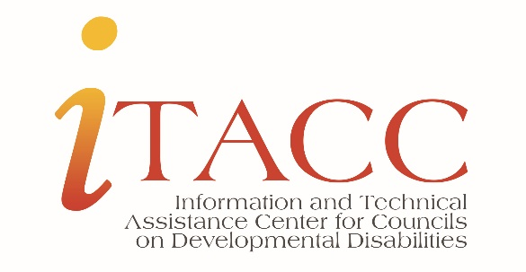
Membership compliance resource - worksheet
DD Act requirements are presented in the left column with areas to insert State/Territory specific data.
The right column can be used to insert information about current or proposed council members for the State/Territory DD Council.
The comparison format will enable one to explore specific areas of membership requirements with current membership appointments for a State/Territory and help identify areas of membership compliance that may need to be addressed.
DD Act Requirements | Current or Proposed Council Membership
60% of the Council members must be public/citizen members representing individuals with developmental disabilities; parents or guardians of children with DD or guardians of adults with DD who cannot advocate for themselves. | Perform the math calculation on the total number of members to determine if the Council has met the minimum of 60% citizen or public members.  What is 100% if [insert # of required agency/organization representatives] is 40%?  100 multiplied by the number of required agency/organization representatives divided by 40 = the number of citizen members needed to reach the minimum 60% required. Always round up to ensure compliance.
Public/Citizen member requirements.  - 1/3 individuals with DD.  - 1/3 parents or guardians of children with DD or guardians of adults with DD with mentally impairing conditions AND who cannot advocate for themselves.  - 1/3 a combination of the 1st two categories (members from EACH category)  - One member must be a person with DD or an immediate relative or guardian of a person with DD who lives or previously lived in an institution. | Current or Proposed Council Appointees (list)  # of individuals with developmental disabilities  # of parents or guardians of children with DD  # of immediate relatives or guardians of adults with intellectual and developmental disabilities and who cannot advocate for themselves  Identify who meets this criterion in the list above.  Name the category of membership the individual fills in on the appointment letter.
Employees of State agencies  Managing employees of agencies or organizations that receive Council funds | List the people who work for a state agency that receives Council funds.  List the people who are managing employees of an agency or organization that receives Council funds.  If the Council provides Council funds to state agencies and other organizations AND people from these categories are employees please review the DD Act, Section 125(b)(3)(B)
DD Act Requirements on composition  - Special Education: Individuals with Disabilities Education Act (IDEA)  - Vocational Rehabilitation Act of 1973  - Aging: Older Americans Act of 1965 (OAA)  - Maternal and Child Health Program: Title V of Social Security Act (SSA)  - Medicaid: Title XIX of Social Security Act (SSA)  - Protection and Advocacy Agency (P&A)  - University Center for Excellence on Developmental Disabilities (UCEDD)  2 additional members are required and must be from the following categories and should be appointed by the Governor and subject to term limits:  - Local or non-governmental agency concerned with services for people with DD.  - Private, non-profit group concerned with services for people with DD. | Current or Proposed Council Appointees (list)  Do the people listed have sufficient authority to engage in policy planning and implementation on behalf of the department, agency, or program they are representing? If not, ensure someone with sufficient authority is the member.  These appointments are term limited and to the agency. Name the agency in the appointment letter. If the individual is named in the letter and they leave the agency, the member would need to be replaced. If the individual is not named in the appointment letter, the representative would be named by the agency and have sufficient authority to engage.
Diversity: Race/Ethnicity and Gender for the State/Territory  Race/Ethnicity (US Census Bureau data) %  Black/African American %  Hispanic/Latino %  White alone, not Hispanic or Latino %  American Indian & Alaska Native alone %  Asian, alone %  Two or more races %  Add additional categories as appropriate and based on data sets.  Gender (US Census Bureau data) %  Female %  Male % | Current or proposed member diversity and gender (apply the race/ethnicity/gender percent to the citizen/public member number – list the number of members needed for each category)
Geographic Representation for the State  Rural %  Urban %  North  South  East  West  Central | Current or proposed member geographic location (apply the rural/urban percent to the citizen/public member number and list the number of members needed for urban/rural categories. Indicate the number of citizen members for the broad geographic areas of the state.
Cross-disability  Intellectual disability  Physical disability  Intellectual and physical disability (both)  Add categories as appropriate.  Examples of developmental disabilities: Autism Cerebral Palsy, Fetal Alcohol Syndrome, Brain injury (before age 22); Down Syndrome, Spina Bifida. All must meet the federal definition as defined in the DD Act of 2000. | Current or proposed member - disability representation. List the number of citizen/public members representing the disability categories.

