Instructions for Account Registration
HDI Learning – University of Kentucky Human Development Institute

Follow these steps for successful account creation
Summary: To create an account, you must first select the course(s) you wish to purchase. Proceed to checkout and you will create your account from there.

- Go to HDI Learning – University of Kentucky Human Development Institute

- Scroll down to the types of products we offer
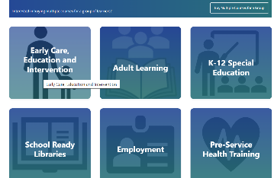

- Select the type of product you are searching for or simply use the search bar for specific courses. The search bar is located at the top right of the hdilearning.org webpage. Note: You will be choosing “DD Council Training” located at the bottom of the homepage

- This is the MOST IMPORTANT step! If you are purchasing a course for yourself, select ‘For Myself’ (see steps 5-6)
$0.00 / student
For Myself For Groups

If you are purchasing for a group(s), select ‘For Groups’ (see steps 7-10)
$0.00 / student
For Myself For Groups

- After selecting ‘For Myself’, you will be taken to ‘Checkout’. You can also add a course individually through the ‘Add to Cart’ option on the course page.

- Enter your information and select ‘Continue’. Now your account has been created successfully!

- If you are purchasing ‘For Groups,’ simply ‘Add to Cart’ and view your cart. This is the best way to purchase for another person!

- Add the number of seats you want to pay for. If you are purchasing only 1 seat, please enter ‘1’.

- Proceed to ‘Checkout’ where you will be presented with a billing page. (Remember, all DD Council Training Courses are free to you!) Fill this out and at the bottom of the page it will ask for a group name. Once setup and purchase are complete, the system will create a ‘Group Management’ tab on your account.

- Click the ‘Group Management’ tab and find your group. There is a ‘User’ button that will allow you to add & invite staff members. This will create their account for them. Your group members will be able to login with that information and take the course using their account. The director’s billing info will be kept separate from the staff member’s account.

